Install Python
Contents
Install Python 1
Install Python 1
Install Visual Studio Code 2
Setup Visual Studio Code to Edit Python Programs 3
Tutorial: Hello World! 4

Time required: 30 minutes

Install Python
There is a version of Python for almost any operating system. These directions are for Windows.
NOTE: Kali Linux and most distributions of Linux already have Python installed.
Watch this Video Walkthrough.
- Go to https://www.python.org/downloads
- Click Download Python 3.12.1 (This was the latest version as of this writing. Download the latest version.)
- Double Click the file you downloaded to start the installation.

- Click Customize installation.
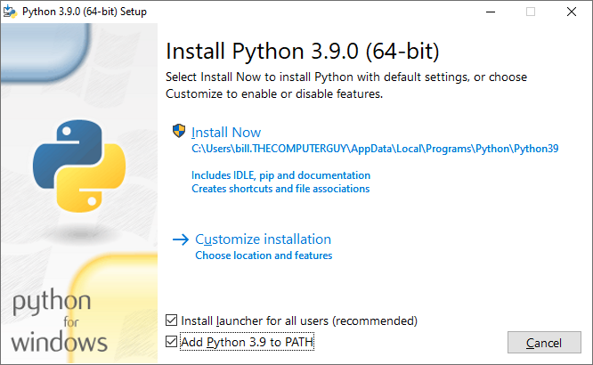
- Click Next until you come to Advanced Options.
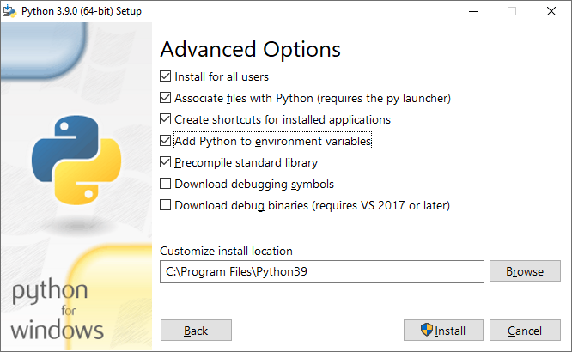
- Click Install Now.
- Setup should be successful.

Install Visual Studio Code
There is extensive information on how to get started with Visual Studio Code and Python on the Visual Studio Code website.
- Go to code.VisualStudio.com You want to find Visual Studio Code.
- Download and install the System Installer 64 bit version of Visual Studio Code for your operating system.
- During the installation: Select Additional Tasks, select the following items. You can create a desktop icon if you wish.
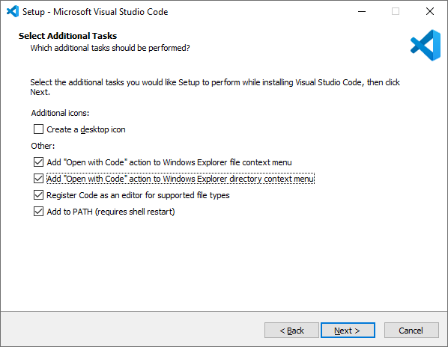

Setup Visual Studio Code to Edit Python Programs
- Run Visual Studio Code.
- Go to the Extensions button on the left navigation bar search for Python. You will see Python IntelliSense by Microsoft. Click Install.
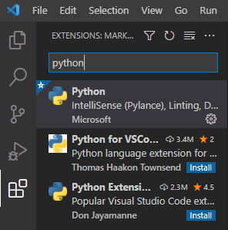

Tutorial: Hello World!
This is traditionally the first program written in a new programming language. It is a good way to test your development environment to make sure everything is working.
We will write and run the traditional “Hello World!” program from a Python program file.
- Launch Visual Studio Code.
- Click File Save As. Save your program as hello_world.py
- Enter the following code required to print a Hello World! message.
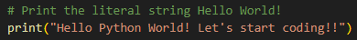
- Press F5 to run the program.
- Your program should print Hello World! in the terminal.
- Example run:
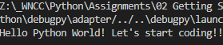
Congratulations! You created your first program in Python. You are ready to start on your programming journey!

